Министерство образования и молодежной политики Свердловской области

ГАПОУ СО «Екатеринбургский колледж транспортного строительства»

Отчет по ТРПО. Лабораторная работа №5  
**«Использование стилей в WPF-приложениях».**

Выполнил: Гордейчик С.А.

Группа: ПР-31

Преподаватель: Бушуева Е.В.

2024

Разметка (задание 1):

<Window x:Class="Buttons.MainWindow"

xmlns="http://schemas.microsoft.com/winfx/2006/xaml/presentation"

xmlns:x="http://schemas.microsoft.com/winfx/2006/xaml"

xmlns:d="http://schemas.microsoft.com/expression/blend/2008"

xmlns:mc="http://schemas.openxmlformats.org/markup-compatibility/2006"

xmlns:local="clr-namespace:Buttons"

mc:Ignorable="d"

WindowStartupLocation="CenterScreen"

Title="ButtonsWindow" Height="450" Width="800">

<Window.Resources>

<Style TargetType="Button" x:Key="DocButton">

<Setter Property="Background" Value="DarkBlue"/>

<Setter Property="Foreground" Value="White"/>

<Setter Property="FontFamily" Value="Verdana"/>

<Setter Property="Padding" Value="5"/>

<Setter Property="Margin" Value="5"/>

<EventSetter Event="Click" Handler="Button_Click"/>

</Style>

<Style BasedOn="{StaticResource DocButton}" TargetType="Button" x:Key="ActiveDocButton">

<Setter Property="Background" Value="DarkRed"/>

</Style>

</Window.Resources>

<StackPanel Orientation="Horizontal" VerticalAlignment="Top">

<Button Style="{StaticResource ActiveDocButton}">Открыть</Button>

<Button Style="{StaticResource DocButton}">Обработать</Button>

<Button Style="{StaticResource DocButton}">Сохранить</Button>

<Button Padding="5" Margin="5">Закрыть</Button>

</StackPanel>

</Window>

Код (задание 1):

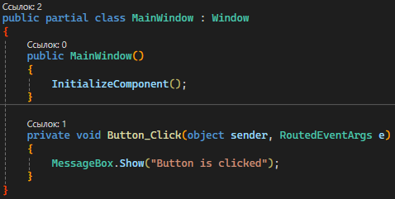

Снимок экрана (задание 1):

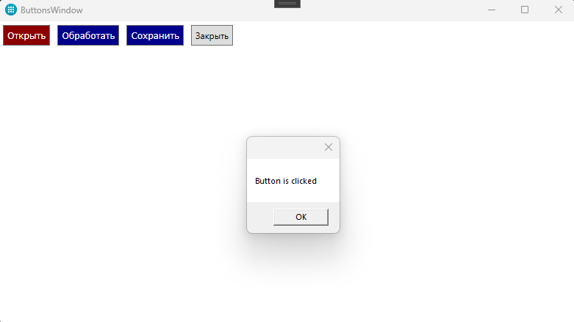

Разметка (задание 2):

<Window x:Class="MultiEdit.MainWindow"

xmlns="http://schemas.microsoft.com/winfx/2006/xaml/presentation"

xmlns:x="http://schemas.microsoft.com/winfx/2006/xaml"

xmlns:d="http://schemas.microsoft.com/expression/blend/2008"

xmlns:mc="http://schemas.openxmlformats.org/markup-compatibility/2006"

xmlns:local="clr-namespace:MultiEdit"

mc:Ignorable="d"

WindowStartupLocation="CenterScreen"

Title="MultiEdit" Height="460" Width="800" ResizeMode="CanMinimize">

<Window.Resources>

<Style x:Key="LargeTextBoxStyle" TargetType="{x:Type TextBox}">

<Setter Property="FontSize" Value="20"/>

<Setter Property="Height" Value="100"/>

<Setter Property="Width" Value="200"/>

<Setter Property="TextWrapping" Value="Wrap"/>

<Setter Property="VerticalScrollBarVisibility" Value="Auto"/>

</Style>

<Style x:Key="SmallTextBoxStyle" TargetType="{x:Type TextBox}">

<Setter Property="FontSize" Value="12"/>

<Setter Property="Height" Value="100"/>

<Setter Property="Width" Value="200"/>

<Setter Property="TextWrapping" Value="Wrap"/>

<Setter Property="VerticalScrollBarVisibility" Value="Auto"/>

</Style>

<Style x:Key="LargeTextBoxActiveStyle" TargetType="{x:Type TextBox}" BasedOn="{StaticResource LargeTextBoxStyle}">

<Style.Triggers>

<Trigger Property="IsFocused" Value="True">

<Setter Property="Height" Value="200"/>

<Setter Property="Width" Value="300"/>

</Trigger>

</Style.Triggers>

</Style>

<Storyboard x:Key="TextBoxHeightAnimation">

<DoubleAnimation Storyboard.TargetProperty="Height" Duration="0:0:0.5"/>

</Storyboard>

</Window.Resources>

<Grid>

<Grid.ColumnDefinitions>

<ColumnDefinition Width="*"/>

<ColumnDefinition Width="*"/>

</Grid.ColumnDefinitions>

<Border Grid.Column="0" Background="#FFF3F3F3" BorderThickness="1,0,1,0" BorderBrush="#FFCCCCCC">

<Grid>

<Grid.RowDefinitions>

<RowDefinition Height="*"/>

<RowDefinition Height="auto"/>

</Grid.RowDefinitions>

<Border Background="#FFD1E1F7" Grid.RowSpan="2"/>

<StackPanel Margin="10">

<TextBox x:Name="largeTextBox" Style="{StaticResource LargeTextBoxStyle}" TextChanged="TextBox_TextChanged"/>

<TextBox Style="{StaticResource SmallTextBoxStyle}" Text="Small Text Box 1"/>

<TextBox Style="{StaticResource SmallTextBoxStyle}" Text="Small Text Box 2"/>

</StackPanel>

</Grid>

</Border>

<Border Grid.Column="1" Background="#FFF3F3F3" BorderThickness="1,0,1,0" BorderBrush="#FFCCCCCC">

<Grid>

<Grid.RowDefinitions>

<RowDefinition Height="*"/>

<RowDefinition Height="auto"/>

</Grid.RowDefinitions>

<Border Background="#FFD1E1F7" Grid.RowSpan="2"/>

<StackPanel Margin="10">

<TextBox x:Name="largeTextBox2" Style="{StaticResource LargeTextBoxStyle}" TextChanged="TextBox_TextChanged"/>

<TextBox Style="{StaticResource SmallTextBoxStyle}" Text="Small Text Box 3"/>

<TextBox Style="{StaticResource SmallTextBoxStyle}" Text="Small Text Box 4"/>

</StackPanel>

</Grid>

</Border>

<Grid Grid.Column="0" Grid.ColumnSpan="2">

<Line X1="0" Y1="0" X2="1" Y2="0" Stroke="#FFCCCCCC" StrokeThickness="1" VerticalAlignment="Bottom"/>

</Grid>

</Grid>

</Window>

Код (задание 2):

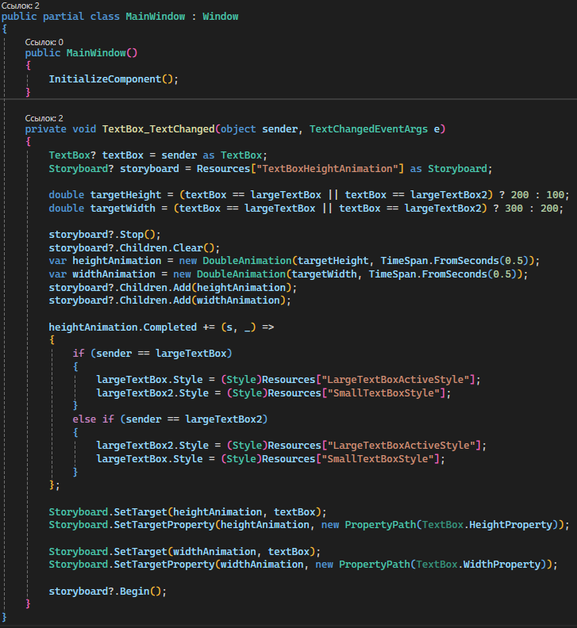

Снимок экрана (задание 2):

